ENDURING POWER:
the Middle Eastern and Iranian Woman’s Story
— Photography Exhibit —
Resource Center for Nonviolence, Santa Cruz, CA
November 2 – December 17, 2015

– Artist Bios -

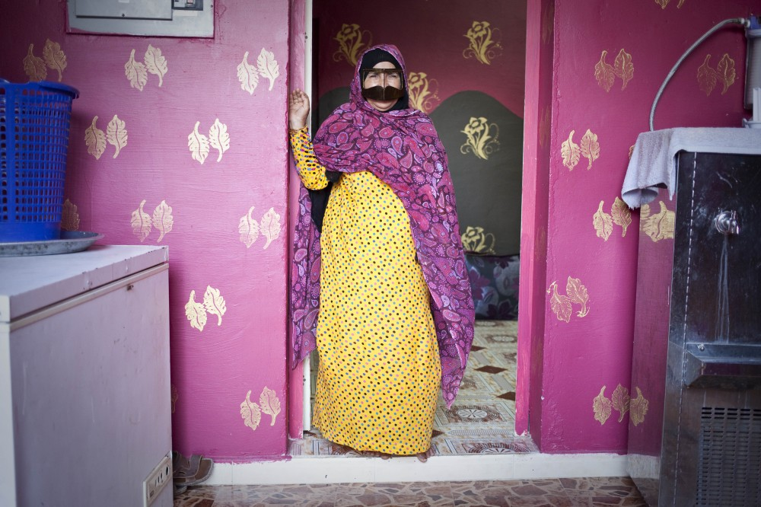

Razan Alzayani is a Bahrain born photographer who has been working in the Gulf region as a visual storyteller for over five years, continually enjoying the interplay of working with still and video mediums. She currently works as a video journalist for the AssociatedPress based in Dubai. Prior to that, Razan worked as a multimedia producer and later as a staff photojournalist for The National Newspaper based in Abu Dhabi. With a degree from Boston University, an impressive resume and several awards over the last two years, she is a very strong contributor to this exhibition, showcasing her passion for issues that involve women and communities that are often misrepresented or that are hard to access.
http://razanalzayani.com/ Twitter @ralzayani Instagram @razanalzayani

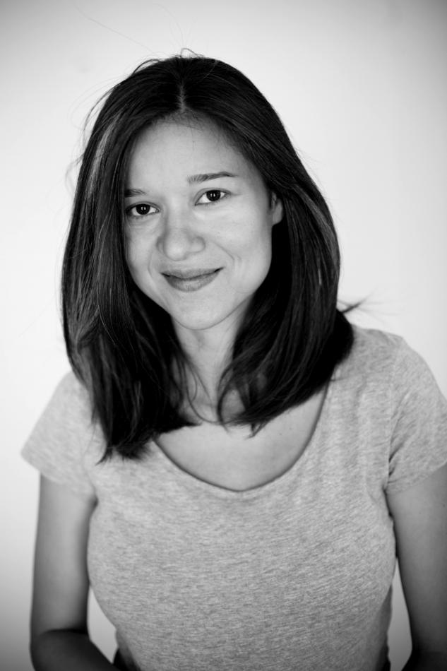
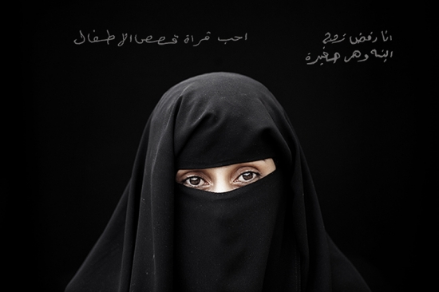
Laura Boushnak is a Kuwaiti-born Palestinian photographer. Her work ranges from conflict photography to pictorial storytelling. After completing a BA in sociology at the Lebanese University, Boushnak began her photography career covering news for the Associate Press in Lebanon, and later as a photo editor and photographer for Agence France‐Presse (AFP). Her nine-year wire service experience included covering hard news in conflicts such as the war in Iraq and the 2006 Israel‐Hesbollah war. Her photographs have been published in the New York Times, The Guardian, The National Geographic, and Le Monde, among others. Since 2008, Boushnak has been working as a freelance photographer, devoting more time to her long‐term projects and focusing on Arab women and education as highlighted in her “I Read I Write” series, seen here as part of the Enduring Power exhibition.
In addition, Boushnak also co‐founded RAWIYA collective, bringing together the
work and experience of female photographers from the Middle East. She was
recently named one of the 2014 TEDGlobal fellows.
http://www.lauraboushnak.com/ @LauraBoushnak @lauraboushnak

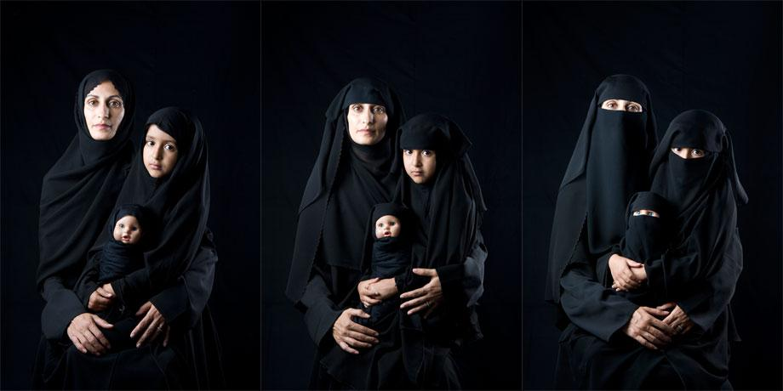
Boushra Y. Almutawakel was born in Sana'a, Yemen. She studied in the United
States and in Yemen, obtaining a BSBA in International Business at the American
University in Washington, DC. As a student, she became interested in photography,
working as a photojournalist on the university newspaper and yearbook, and as a
photo lab assistant at the School of Communications. Following her return to Yemen
in the mid 90s, she co-founded the Al-Halaqa in Sana'a, an artists' group that created a space for discourse and exhibitions, and forged links with international artists.
In 1999, she was honored as the first Yemeni Woman Photographer by the
Empirical Research and Women's Studies Centre at Sana'a University.
Almutawakel has worked at the Ministry of Human Rights in Sana'a, focusing on
women's issues, as well as a consultant on cultural affairs for the Yemeni Embassy in
Washington, organizing events such as the Smithsonian symposium “Windows on
the Cultural Heritage of Yemen,” and other exhibits, lectures, concerts and film
screenings on Yemen.
Her personal photography projects have received much acclaim for their work
dealing with women and identity, including the “Mother/Daughter/Doll” and “Veil Unveil” series featured here as part of the Enduring Power exhibition. http://www.newrepublic.com/article/118055/boushra-almutawakel-hijab-veil-series. See article: New Republic article: The Case of the Disappearing Woman

Hagar Sobeea is a graphic artist and documentary photographer based in
Alexandria, Egypt. Sobeea received her masters in set design at the University of
Alexandria. Her most recent documentary photography projects include “365Days,”
and “100Signs and 100Strangers.”
Her portrait of a young girl, as seen in the Enduring Power exhibition, was taken in
the impoverished neighborhood of El Max in Alexandria, Egypt. In a neighborhood
well‐known for its fishing community and the modest homes that lie directly on the canal, Sobeea observed a young girl’s refreshing display of toughness as the only girl who was playing with a group of boys.

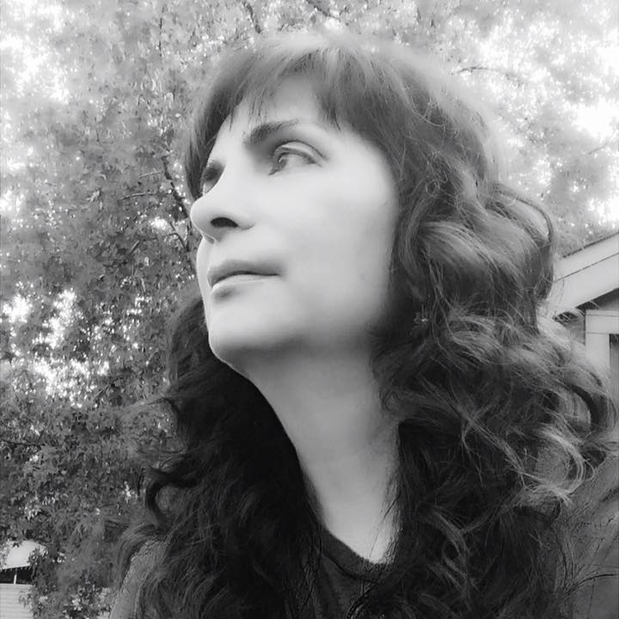
Hamideh Zolfaghari is an Iranian photographer based in Tehran. Her photographs highlight the extreme contrasts between men and women in the Iranian culture, and draw links between the nomadic tribal life in Iran and the modern life of those who live in major cities like Tehran.
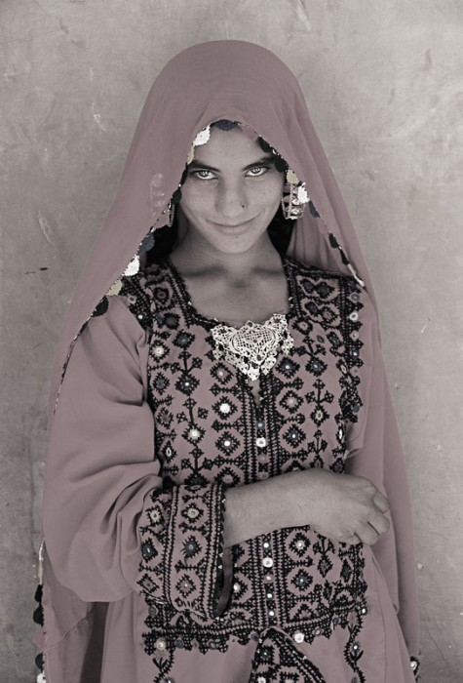
Zolfaghari studied Creative Photography at San Jose State University, later worked as a photographer for UNICEF, and for the past two decades, has committed to herself to “tell the stories of those that cannot express it themselves.”
Her photographs have been exhibited in galleries across France, England, Switzerland and California, receiving numerous awards and honors for her work along the way.
http://www.hamidehz.com

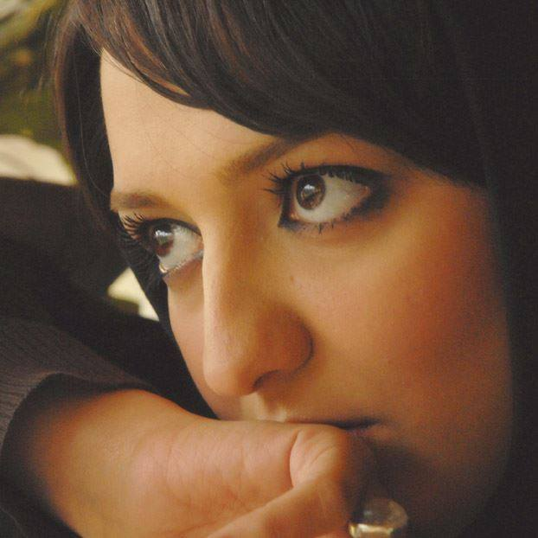
Maryam Saeedpoor is an Iranian photographer based in Tehran. She studied photojournalism at the University of Tehran and has worked as a freelance photographer for the past 10 years. Saeedpoor’s work has been published in various Iranian news publications, including “Hamshahri” newspaper. https://www.facebook.com/maryam.saeedpoor?fref=ts

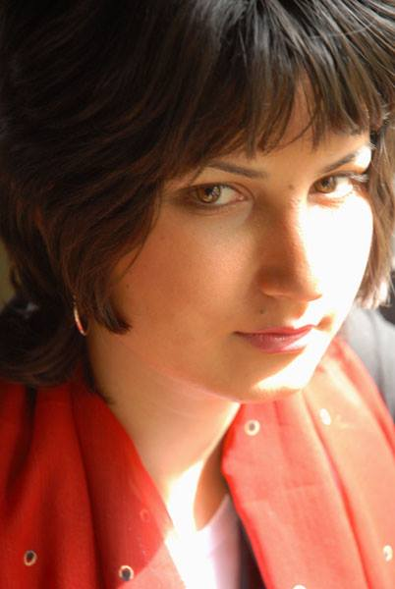
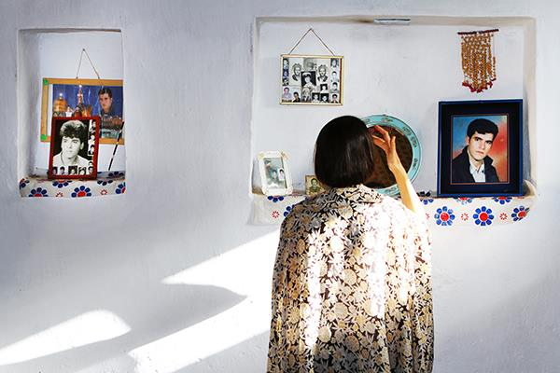
Sara Sasani is an Iranian photographer based in Tehran. She has an associate’s degree in photojournalism and a BA in sociology from Azad University. Sasani’s work has been exhibited in over 10 photography exhibitions and published in such books as “My Yazd” by X-Change Culture Science, and“Iran, Winter Journey” by Fotohof publishing.
https://www.facebook.com/sara.sasani.56

